**Best Practices/Guidelines for ABAP**

1. Never use * in the query. Fetch the data of only those columns which are required.

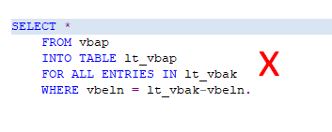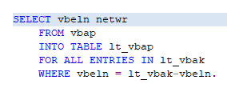

1. Columns fetching sequence needs to be same as that of data dictionary column sequence

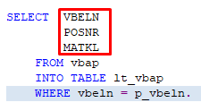 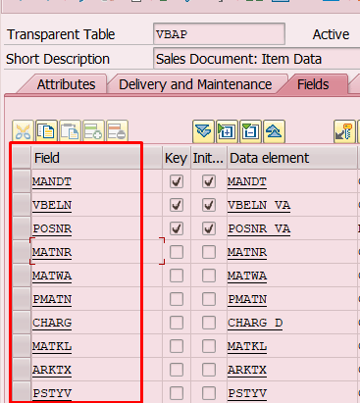

1. Where condition column sequence needs to be same as that of the data dictionary column sequence.

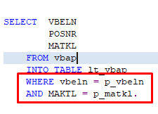

1. Never use Corresponding in the query. Instead if possible select field in order in which you defined them in structure of internal table

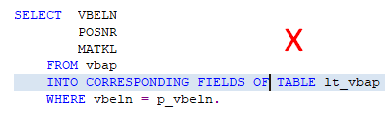

1. For traditional databases avoid using JOIN, use FOR ALL ENTRIES IN.

Because when you use FOR ALL ENTRIES IN only single table is load

While JOIN multiple tables are loaded, traditional DBs might not work efficiently in such case.

1. For fetching data from foreign key tables / dependent tables – check for SY-SUBRC or internal table not initial condition.

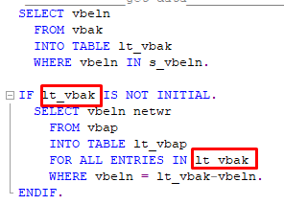

1. Use binary search in read tables.



1. Use parallel cursor in nested loops

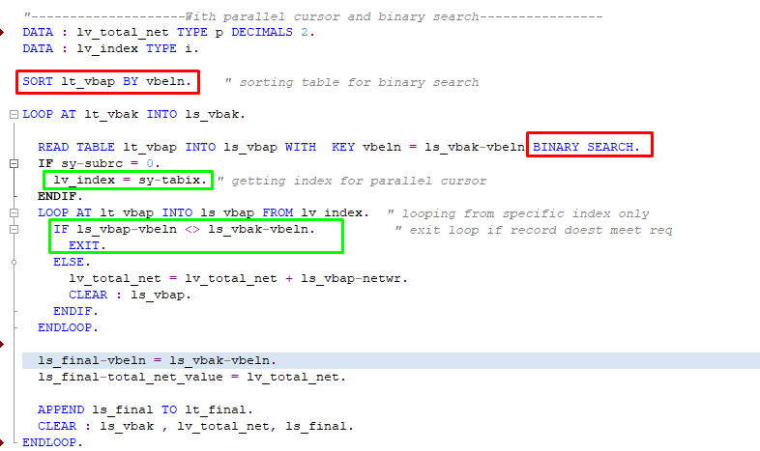

1. For multiple conditions, use case conditional statement rather than if condition statement.

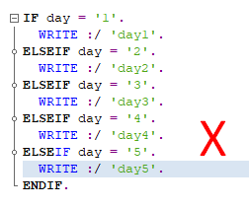 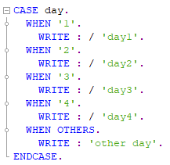

1. Never write the queries inside the loop. Instead use READ TABLE.
2. Depends upon the requirement, create secondary indexes to improve the performance.